

Project Report on :

Online Food Ordering

Submitted for the partial fulfillment of Project in

Bachelor Of Computer Application

( Semester – VI )

-: Submitted To :-

Department Of IT Harivandana College, Rajkot.

-: Affiliated To :-

Saurashtra University, Rajkot

-: Submitted By :-

Student Name : Kher Akshaykumar Makabhai

Enroll no :

-: Under the Guidance of :-

Prof. Ashwin Rathod (Professor & Head)

Prof. Dharmendra Ambani (Lecturer & Project in charge)

Prof. Shivam Trivedi (Lecturer & Project in charge)

On

**MealMonkey FoodOrdering**

Developed At

**Harivandana College**

**MealMonkey FoodOrdering**

**CERTIFICATE**

**This is to certify that the project report entitled**

**____________________ submitted to Harivandana College Rajkot,**

**in partial fulfilment of the requirement for the Current Semester**

**B.C.A SEM V - 2021, work carried out by _____________________.**

**The project process is carried during the present semester in**

**computer laboratories under the supervision of a guide preferably**

**from the college. During this semester, the student has gone through**

**several theoretical reports such as SDLC, Database Management**

**System, SoftWare Engineering etc. The matter embodied in this project is**

**satisfactory done by the student for the fulfilment of the required**

**semester.**

**Head of Department Internal Guide**

**Dr. Ashwin Rathod**

**Prof. Dharmendra Ambani**

**Prof. Shivam Trivedi**

**ACKNOWLEGEMENT**

* We are very thankful to the project coordinator of Prof. Harshad

Fefar of Harivandana College, who has provided us a lot of support & guidance from the beginning to the end of the project development.

* A work of this nature would not have been possible without the encouragement and meticulous attention received from them. The faculties has also played a vital role in building up my project website, under their guidance and training it became much easier to develop a project.

* A work of this nature would not have been possible without encouragement and meticulous .

MealMonkey FoodOrdering

|  |  |  |
| --- | --- | --- |
| **No** | **Subject Title** | **Page No.** |
| **1** | **Introduction** | **1** |
| **2** | **Literature Survey** | **4** |
| **3** | **Project Management**  ❖ **Project planning and Scheduling** | **11** |
| **4** | **Requirements Specification** | **16** |
| **5** | **System Design**   * Usecase * Data Flow Diagram | **17** |
| **6** | **Implimentation**   * Data dictionary * product * admin * buy * category * register * contact * comments **Screenshot** | **21** |
| **7** | **Testing**  ❖ Testing Levels ❖ Types of testing | **44** |
| **8** | **Future Work** | **48** |
| **9** | **Conclusion** | **50** |
| **10** | **References** | **52** |

**1**

**INTRODUCTION**

**Project Summery**

* My Project is basically Online Food Ordering Website regarging like Many Food Website Type Zomato,Swiggy,Dunzo,etc..
* In This Website are Helpful for Small Kitchen. Like Many Indian Start-up zomato,swiggy are connected and typed up Big Restorant and big hotels. But in my System are uselly in This type.
* My Website Through Small Kitchen best Items Sellout. I developed Bridge(Website) and Connect User and Food Items Seller.
* The Website is developed in PHP (XamppServer), HTML, Java Script and MySQL for the Database.
* After all the entries administrator can view orders of all customers which Type Dish ordered users .
* Administrator are checked which delivery boy are available in this current time or not and Check Order Status.
* Delivery Boy are Login & Logout Functionality Available.
* All the entry fills up by the user, so user can get all details of products. User can easily order products.
* Payment System are available (Paytm). when You order Any Dish after Payment Method are available .
* Admin are check Payment Status And Order Status.
* The Website maintains the data of the user and it’s searching results for the order online products.

**SCOPE**

* **Language Scope :** 
  + Language – HTML , CSS ,PHP , JQUERY , JAVASCRIPT , MYSQL Connectivity
* **Project Scope :** 
  + The scope of the project is defining what will and will not be supported by the application. This application will enable servers to manage accounts: order products, fill out and submit order, we provides only cash on delivery payment method And Paytm Payment Method using third Party API.

* + After order complete user can check when they ordered product.admin can add products, category and manage it. Users also search his choices product in Kitchenware and Hardware Product Website. we currently provides only in Rajkot city.

**PROJECT BOUNDRY :**

* + Require Xammp web server

**DURATION :**

In 16 weeks my website will be completed.

Analysis : 2 weeks

Design : 2 weeks

Coding : 7 weeks

Testing : 3 weeks

**2**

**LITERATURE**

**SURVEY**

**HTML Overview :**

* HTML was originated by Tim Berners-Lee
* HTML developed a few years ago as a subset of SGML (Standard Generalized Mark-up Language), which is a higher-level mark-up language that has long been a favorite of the Department of Defense.
* Any HTML document is also valid for SGML
* HTML is a Hyper Text Markup Language that is used to develop web pages ➢ HTML is not a programming language like C, C++ and Java etc.
* It is a cross platform markup language that is design to be flexible enough to display text and other elements like graphical on a variety of views.
* The HTML documents consist of special Tags that are embedded in an ASCII document.
* Web browser like Internet Explorer, Netscape Navigator etc, interprets these Tags.

**JAVASCRIPT Overview :**

* JavaScript was designed to add interactivity to HTML pages.
* JavaScript is a scripting language (a scripting language is a lightweight programming language)
* A JavaScript consists of lines of executable computer code
* A JavaScript is usually embedded directly into HTML pages
* JavaScript is an interpreted language (means that scripts execute without preliminary compilation)
* Everyone can use JavaScript without purchasing a license.

**MYSQL Overview :**

* **MYSQL DATABASE MANAGEMENT SYSTEM :** 
  + MySQL, the most popular Open Source SQL database management system, is developed, distributed, and supported by MySQL.
  + MySQL is a commercial company, founded by the MySQL developers. It is a second generation Open Source Company that unites Open Source values and methodology with a successful business model.
  + The MySQL Web site ([http://www.mysql.com/)](http://www.mysql.com/) provides the latest information about MySQL software and MySQL.
  + The official way to pronounce “MySQL” is “My Ess Que Ell” (not “my sequel”), but we don't mind if you pronounce it as “my sequel” or in some other localized way.
* **MYSQL FEATURES :** 
  + MySQL, the most popular Open Source SQL database management system, is developed, distributed, and supported by MySQL.
  + MySQL is a commercial company, founded by the MySQL developers. It is a second generation Open Source Company that unites Open Source values and methodology with a successful business model.
  + The MySQL Web site ([http://www.mysql.com/)](http://www.mysql.com/) provides the latest information about MySQL software and MySQL.
  + The official way to pronounce “MySQL” is “My Ess Que Ell” (not “my sequel”), but we don't mind if you pronounce it as “my sequel” or in some other localized way.

**PHP Overview :**

* The full form of PHP is “Hypertext Preprocessor”. Its original name is “Personal Home Page”.
* Rasmus Lerdorf software engineer, Apache team member is the creator and original driving force behind PHP. The first part of PHP was developed for his personal use in late 1994.
* By the middle of 1997, PHP was being used on approximately 50,000 sites worldwide.
* PHP is server-side scripting language, which can be embedded in HTML or used as a stand-alone.
* PHP doesn‟t do anything about what a page looks and sounds like. In fact, most of what PHP does is invisible to the end user.
* Someone looking at a PHP page will not necessarily be able to tell that it was not written purely in HTML, because usually the result of PHP is HTML.
* PHP is an official module of Apache HTTP Server.
* PHP is fully cross-platform, meaning it runs native on several flavors of UNIX, as well as on Windows and now on Mac OS X.
* **Advantages of PHP:**

* + - ***Cost*:** PHP costs you nothing. It is open source software and doesn‟t need to purchase it for development.
    - ***Ease of Use*:** PHP is easy to learn, compared to the others. A lot of Ready-made PHP scripts are freely available in market so, you can use them in your project or get some help from them.
    - ***HTML- Support:*** PHP is embedded within HTML; In other words, PHP pages are ordinary HTML pages that escape into PHP mode only when necessary. When a client requests this page, the web server preprocesses it. This means it goes through the page from top to bottom, looking for sections of PHP, which it will try to resolve.
    - ***Cross-platform compatibility*:** MySQL run native on every popular flavor of

UNIX and windows. A huge percentage PHP and of the world‟s HTTP servers run on one of these two classes of operating system.

* + - ***PHP is compatible with the three leading Web servers:*** Apache HTTP Server for UNIX and Windows, Microsoft Internet Information Server, and Netscape Enterprise Server. It also works with several lesser-known servers, including Alex

Blits‟ fhttpd, Microsoft’s Personal Web Server, AOL Server and Omnicentrix‟s Omni server application server.

* + - ***Stability:*** The word stable means two different things in this context:
    - The server doesn’t need to be rebooted often
      * + The software doesn’t change radically and incompatibly from release to release.
        + **To our advantage, both of these apply to both MYSQL and PHP.**

* **Speed:** PHP is pleasingly zippy in its execution, especially when compiled as an Apache module on the UNIX side. Although it takes a slight performance hit by being interpreted rather than compiled, this is far outweighed by the benefits PHP drives from its status as a Web server module.

**Analysis :**

* When I started My Project First of all I had seen Food Ordering websites Like Zomato, Swiggy, Dunzo etc. And seen their Facility which they provide.

.

* Then I collected the Information about How Actual food ordering website Order system work and hardware product websites then I collect information which i want for my Website.

I have given following facilities in My website.

❖ Client Side :

* Register or Sign in
* Profile, Order History & Logout
* My Cart
* Sorting Categories
* Search Dish
* Shop, About & Contact Us
* Full , Half Dish Ordering
* Cash on Delivery , Paytm & Wallet Payment System
* Coupen Code Use

❖ Admin Side :

* Dashboard
* Login & Logout
* Order Details
* Add Category , Update Category , Delete Category & Active Deactive Dish
* Add User & Active Deactive User
* Add, Update & Active Deative Delivery Boy
* Coupen Code Added & Set Add on And Expire Date
* Dish Add ,Update ,Active & Deactive
* Banner Add, Delete, Edit
* Contact Us
* Website Setting Like (Open Close ,Cart Min Price Set )

**3**

**PROJECT**

**MANAGEMENT**

**Project Planning and Scheduling**

* **3.1.1) Project Development Approach**

• **Software Development Process : Waterfall Model**

In the waterfall model, a project progresses through an orderly sequence of steps from the initial software concept through system testing. The project holds a review at the end of each phase to determine whether it is ready to advance to the next phase - from requirements analysis to architectural design. If the review determines that the project isn't ready to move to the next phase, it stays in the current phase until it is ready.

The waterfall model is document driven, which means that the main work products that are carried from phase to phase are documents. In the pure waterfall model, the phases are also discontinuous - they do not overlap. The following shows how the pure waterfall lifecycle model progresses.

The pure waterfall model performs well for product cycles in which you have a stable product definition and when you're working with well- understood technical methodologies. In such cases, the waterfall model helps you to find errors in the early, low-cost stages of a project. It provides the requirement stability that developers crave. If you're building a well-defined maintenance release of an existing product or porting an existing product to a new plat. Form, a waterfall lifecycle might be the right choice for rapid development.

The pure waterfall model helps to minimize planning overhead because you can do all the planning up front. It doesn't provide tangible results in the form of software until the end of the lifecycle, but, to someone who is familiar with it, the documentation it generates provides meaningful progress throughout the lifecycle.

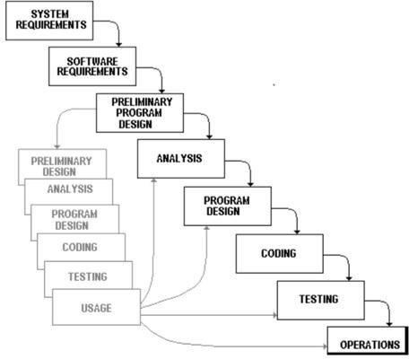

* **3.1.2) Project Plan :**

|  |  |  |
| --- | --- | --- |
| **System Analysis** | **Duration** | **Resource Requirement** |
| System Design and Documentation | 2 WEEKS | All |
| Actual Development | 2 WEEKS | All |
| Unit Testing | 1 WEEKS | All |
| Integrated of System | 1 WEEKS | All |
| Test case preparation | 2 WEEKS | All |
| System Testing | 2 WEEKS | All |
| Bug Fixing | 1 WEEKS | All |

**Schedule Representation :**

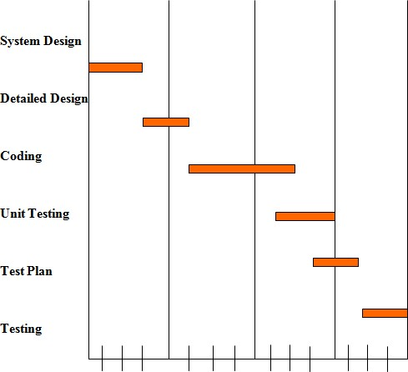

**4**

**Requirements**

**Specification**

**HARDWARE REQUIREMENTS :**

* Intel i3 7th generation And Above
* Minimum 1 TB Hard disk
* Minimum 4 GB RAM
* Mouse, Keyboard ➢ 4x CR-ROM drive OR USB port

**SOFTWARE REQUIREMENTS :**

* Ubuntu 18.04LTS, Window 10 ,7
* Mozilla Fire Fox & Google Chrome latest version
* Xamp web server latest version or wamp server
* PHP 5.6.3
* MySQL 5.5.32
* Microsoft word

**5**

**SYSTEM**

**DESIGN**

**Basic Flow of System**

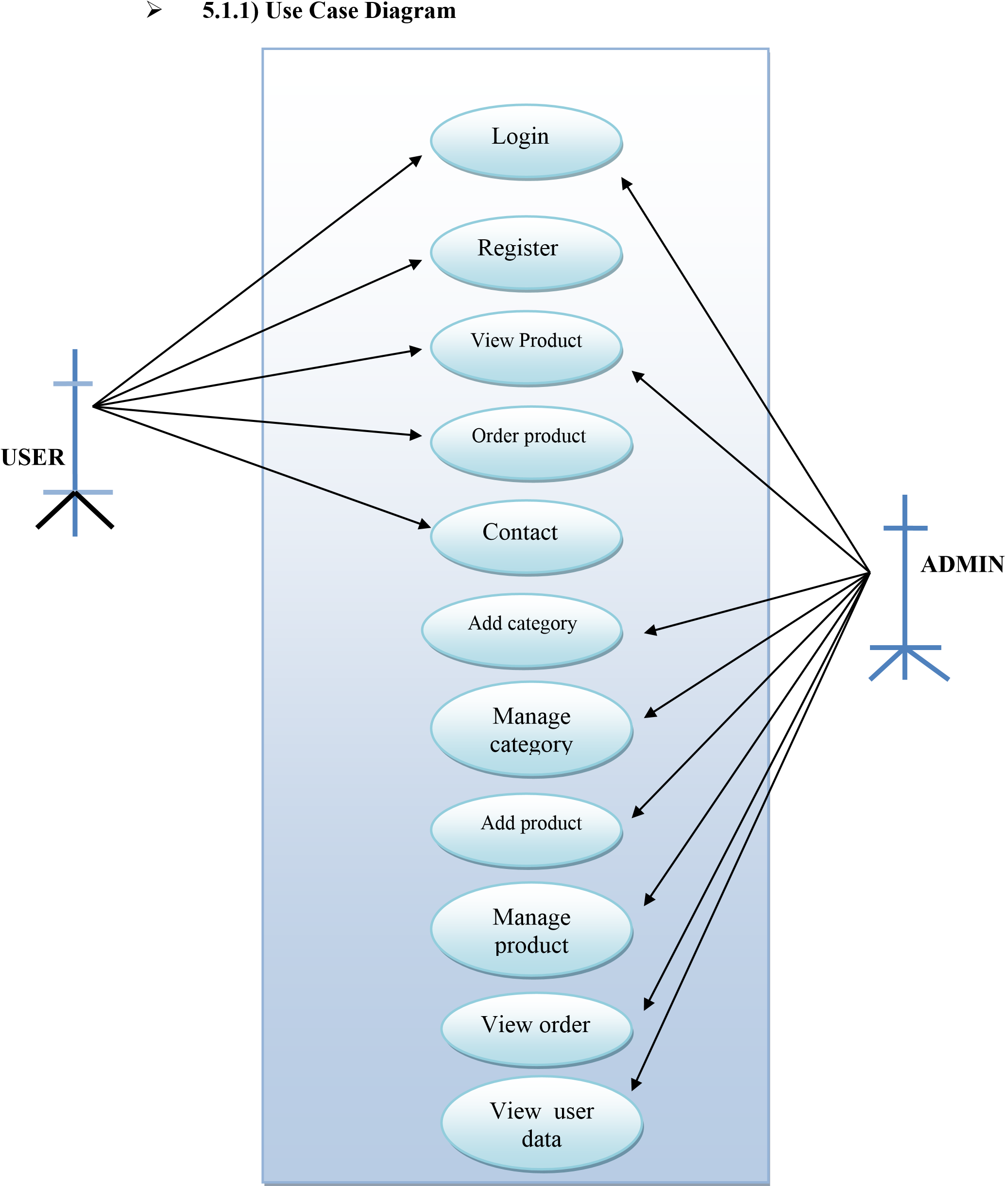

* **5.1.2) Data Flow Diagram**

• **What is a Data Flow Diagrams(DFD)?**

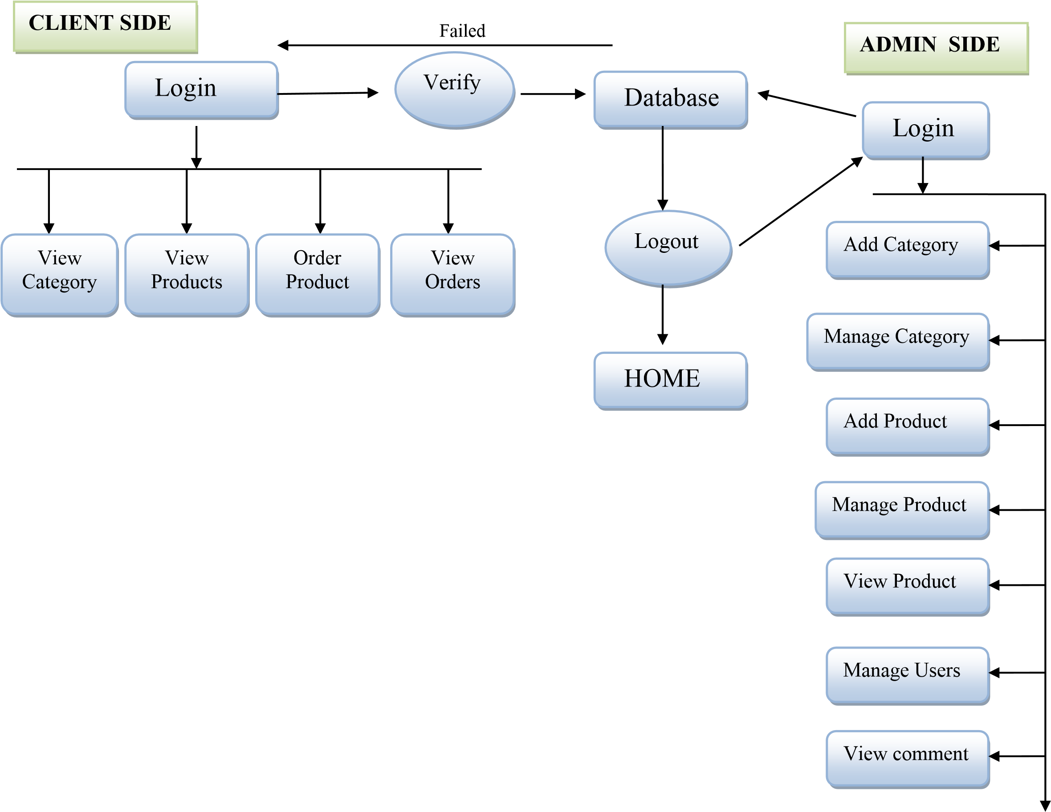✓ Data flow diagrams are commonly used for understanding the system and can be effectively used for analysis. When you are designing an application system, you must first consider the flow of the data into the out of it. A DFD shows the flow of the data through a system. DFD does not show decision or timing of events.

**System Procedural Design**

* **5.2.1) Context Level Diagram :**

REQUEST

RESPONSE



**ADMIN**



**Food Ordering**

**6**

**IMPLEMENTATION**

**Data Dictionary**

* **ADMIN (1)**

|  |  |  |  |
| --- | --- | --- | --- |
| Table Name |  | | Admin |
| Description |  | | Admin Data Store |
| Primary Key |  | | ID |
| Field Name | Type | Size | Constraints |
| ID | Integer | 11 | Not Null |
| Name | Varchar | 50 | Not Null |
| Username | Varchar | 50 | Not Null |
| Password | Varchar | 50 | Not Null |
| Email | Varchar | 50 | Not Null |

* **Banner (2)**

|  |  |  |  |  |
| --- | --- | --- | --- | --- |
| Table Name |  | baanner | | |
| Description |  | This table is used to stored data show dynamically in front page | | |
| Primary Key |  | id | | |
| Key | Field Name | Type | Size | Constraints |
| * | id | Integer | 11 | Not Null |
|  | image | Varchar | 100 | Not Null |
|  | heading | Varchar | 500 | Not Null |
|  | sub_heading | Varchar | 500 | Not Null |
|  | link | Varchar | 100 | Not Null |
|  | link_txt | Varchar | 100 | Not Null |
|  | order_number | Integer | 11 | Not Null |
|  | added_on | datetime | - | Not Null |
|  | status | Integer | 11 | Not Null |

**❖ Category (3)**

|  |  |  |  |  |
| --- | --- | --- | --- | --- |
| Table Name |  | Category | | |
| Description |  | This table is used to maintain and store the information related tto your Category | | |
| Primary Key |  | id | | |
| Key | Field Name | Type | Size | Constraints |
| * | id | Integer | 11 | Not Null |
|  | category | Varchar | 50 | Not Null |
|  | order_number | Integer | 11 | Not Null |
|  | status | Integer | 11 | Not Null |
|  | added_on | datetime | - | Not Null |

**❖ Contact Us (4)**

|  |  |  |  |  |
| --- | --- | --- | --- | --- |
| Table Name |  | Contact Us | | |
| Description |  | This table is used to maintain and store the information related Contact us | | |
| Primary Key |  | id | | |
| Key | Field Name | Type | Size | Constraints |
| * | id | Integer | 11 | Not Null |
|  | name | Varchar | 100 | Not Null |
|  | email | Varchar | 100 | Not Null |
|  | mobile | Varchar | 15 | Not Null |
|  | subject | Varchar | 200 | Not Null |
|  | message | text | - | Not Null |
|  | added_on | datetime | - | Not Null |

**❖Coupon_code(5)**

|  |  |  |  |  |
| --- | --- | --- | --- | --- |
| Table Name |  | Coupon_code | | |
| Description |  | This table is used to maintain and store the information related to your Coupon_code | | |
| Primary Key |  | id | | |
| Key | Field Name | Type | Size | Constraints |
| * | id | Integer | 11 | Not Null |
|  | coupon_code | Varchar | 20 | Not Null |
|  | coupon_type | enum | (‘P’, ‘F’) | Not Null |
|  | coupon_value | Integer | 11 | Not Null |
|  | cart_min_value | Integer | 11 | Not Null |
|  | expired_on | date | - | Not Null |
|  | status | Integer | 11 | Not Null |
|  | added_on | datetime | - | Not Null |

**❖ Delivery_boy (6)**

|  |  |  |  |  |
| --- | --- | --- | --- | --- |
| Table Name |  | Delivery_boy | | |
| Description |  | This table is used to maintain and store the information related to delivery_boy | | |
| Key | Field Name | Type | Size | Constraints |
| * | id | Integer | 11 | Not Null |
|  | name | Varchar | 50 | Not Null |
|  | mobile | Varchar | 50 | NotNull |
|  | password | Varchar | 50 | Not Null |
|  | status | Integer | 11 | Not Null |
|  | added_on | datetime | - | Not Null |

**❖ Dish (7)**

|  |  |  |  |  |
| --- | --- | --- | --- | --- |
| Table Name |  | Dish | | |
| Description |  | This table is used to maintain and store the information related to dish | | |
| Primary Key |  | id | | |
| Key | Field Name | Type | Size | Constraints |
| * | id | Integer | 11 | Not Null |
|  | category_id | Integer | 11 | Not Null |
|  | dish | Varchar | 100 | Not Null |
|  | dish_details | Text | - | Not Null |
|  | image | Varchar | 100 | Not Null |
|  | type | Enum | (‘veg’,  ‘non-veg’ ) | Not Null |
|  | status | Integer | 11 | Not Null |
|  | added_on | DateTime | - | Not Null |

* **Dish_cart (8)**

|  |  |  |  |  |
| --- | --- | --- | --- | --- |
| Table Name |  | dish_cart | | |
| Description |  | This table is used to maintain and store the information related to dish_cart | | |
| Primary Key |  | id | | |
| Key | Field Name | Type | Size | Constraints |
| * | Id | Integer | 11 | Not Null |
|  | user_id | Integer | 11 | Not Null |
|  | dish_details_id | Integer | 11 | NotNull |
|  | qty | Integer | 11 | Not Null |
|  | added_on | DateTime | - | Not Null |

**❖** **Dish_Details (9)**

|  |  |  |
| --- | --- | --- |
| Table Name |  | dish_details |
| Description |  | This table is used to maintain and store the information related to dish_details |
| Primary Key |  | id |

|  |  |  |  |  |
| --- | --- | --- | --- | --- |
| Key | Field Name | Type | Size | Constraints |
| * | Id | Integer | 11 | Not Null |
|  | dish_id | Integer | 11 | Not Null |
|  | attribute | Varchar | 100 | Not Null |
|  | price | Integer | 11 | Not Null |
|  | status | Integer | 11 | Not Null |
|  | added_on | DateTime | - | Not Null |

**❖ Order_details (10)**

|  |  |  |  |  |
| --- | --- | --- | --- | --- |
| Table Name |  | order_details | | |
| Description |  | This table is used to maintain and store the information related to order_details | | |
| Primary Key |  | Id | | |
| **Key** | **Field Name** | **Type** | **Size** | **Constraints** |
| * | Id | Integer | 11 | Not Null |
|  | order_id | Integer | 11 | Not Null |
|  | dish_details_id | Integer | 11 | Not Null |
|  | price | Integer | 11 | Not Null |
|  | qty | Integer | 11 | Not Null |

**❖ Order_master (11)**

|  |  |  |  |  |
| --- | --- | --- | --- | --- |
| Table Name |  | order_master | | |
| Description |  | This table is used to maintain and store the information related to order_details | | |
| Primary Key |  | Id | | |
| Key | **Field Name** | **Type** | **Size** | **Constrains** |
| * | Id | Integer | 11 | Not Null |
|  | user_id | Integer | 11 | Not Null |
|  | name | Varchar | 50 | Not Null |
|  | email | Varchar | 50 | Not Null |
|  | mobile | Varchar | 50 | Not Null |
|  | address | Text | - | Not Null |
|  | total_price | Float | - | Not Null |
|  | coupon_code | Varchar | 20 | Not Null |
|  | final_price | Float | - | Not Null |
|  | zipcode | Varchar | 10 | Not Null |
|  | delivery_boy_id | Integer | 11 | Not Null |
|  | payment_status | Varchar | 20 | Not Null |
|  | payment_type | Varchar | 10 | Not Null |
|  | payment_id | Varchar | 100 | Not Null |
|  | order_status | Integer | 11 | Not Null |
|  | cancel_by | Enum | (‘user’, ‘admin’) | Not Null |
|  | cancel_at | Datetime | - | Not Null |
|  | added_on | Datetime | - | Not Null |
|  | delivered_on | Datetime | - | Not Null |

**❖ Order_status (12)**

|  |  |  |  |  |
| --- | --- | --- | --- | --- |
| Table Name |  | order_status | | |
| Description |  | This table is used to maintain and store the information related to order_status | | |
| Primary Key |  | Id | | |
| **Key** | **Field Name** | **Type** | **Size** | **Constrains** |
| * | Id | Integer | 11 | Not Null |
|  | order_status | Varchar | 50 | Not Null |

**❖ Rating (13)**

|  |  |  |  |  |
| --- | --- | --- | --- | --- |
| Table Name |  | rating | | |
| Description |  | This table is used to maintain and store the information related to items rating | | |
| Primary Key |  | Id | | |
| **Key** | **Field Name** | **Type** | **Size** | **Constrains** |
| * | Id | Integer | 11 | Not Null |
|  | user_id | Integer | 11 | Not Null |
|  | order_id | Integer | 11 | Not Null |
|  | dish_details_id | Integer | 11 | Not Null |
|  | rating | Integer | 11 | Not Null |

**❖ Setting (14)**

|  |  |  |  |  |
| --- | --- | --- | --- | --- |
| Table Name |  | Setting | | |
| Description |  | This table is used to maintain and store the information related to Website Setting | | |
| Primary Key |  | Id | | |
| **Key** | **Field Name** | **Type** | **Size** | **Constrains** |
| * | id | Integet | 11 | Not Null |
|  | cart_min_price | Integet | 11 | Not Null |
|  | cart_min_price_msg | Varchar | 250 | Not Null |
|  | website_close | Integet | 11 | Not Null |
|  | Wellet_amt | Integet | 11 | Not Null |
|  | website_close_msg | Varchar | 250 | Not Null |
|  | refferral_amt | Integet | 11 | Not Null |

**❖ User (15)**

|  |  |  |  |  |
| --- | --- | --- | --- | --- |
| Table Name |  | User | | |
| Description |  | This table is used to maintain and store the information related to User | | |
| Primary Key |  | Id | | |
| **Key** | **Field Name** | **Type** | **Size** | **Constrains** |
| * | Id | Integer | 11 | Not Null |
|  | name | Varchar | 50 | Not Null |
|  | email | Varchar | 50 | Not Null |
|  | mobile | Varchar | 15 | Not Null |
|  | password | Varchar | 100 | Not Null |
|  | status | Integer | 11 | Not Null |
|  | email_verify | Integer | 11 | Not Null |
|  | rand_str | Varchar | 20 | Not Null |
|  | refferral_code | Varchar | 20 | Not Null |
|  | from_refferal_code | Varchar | 20 | Not Null |
|  | added_on | Datetime | - | Not Null |

**❖ Wallet (16)**

|  |  |  |  |  |
| --- | --- | --- | --- | --- |
| Table Name |  | wallet | | |
| Description |  | This table is used to maintain and store the information related to Wallet | | |
| Primary Key |  | Id | | |
| **Key** | **Fields Name** | **Type** | **Size** | **Constrains** |
| * | Id | Integer | 11 | Not Null |
|  | user_id | Integer | 11 | Not Null |
|  | mt | Integer | 11 | Not Null |
|  | msg | Varchar | 500 | Not Null |
|  | type | Enum | (‘in’ , ‘out’ ) | Not Null |
|  | payment_id | Varchar | 50 | Not Null |
|  | added_on | Datetime | - | Not Null |

**DataBase Structure (image)**

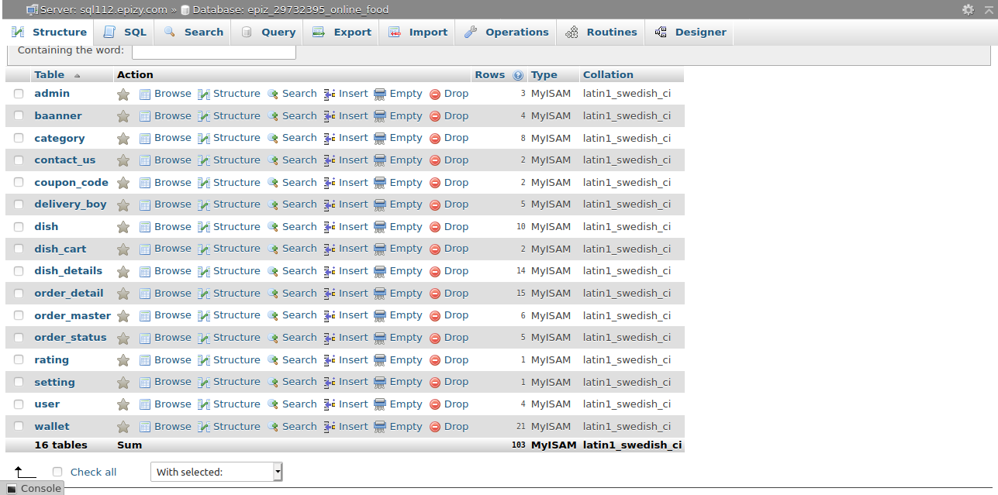

**Front-End Website Layout**

* **Banner Page (Landing Page)**

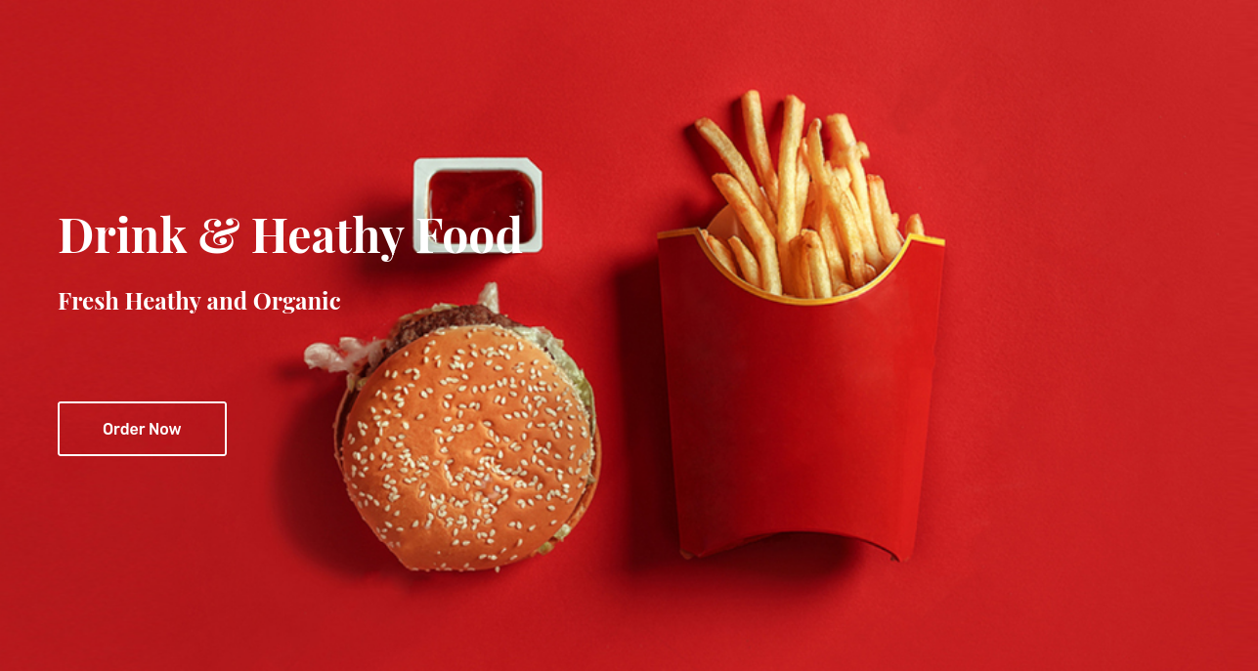

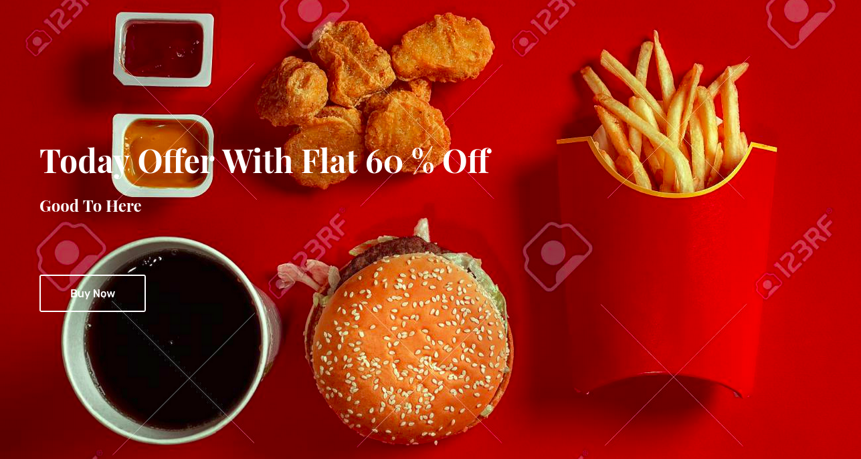

* 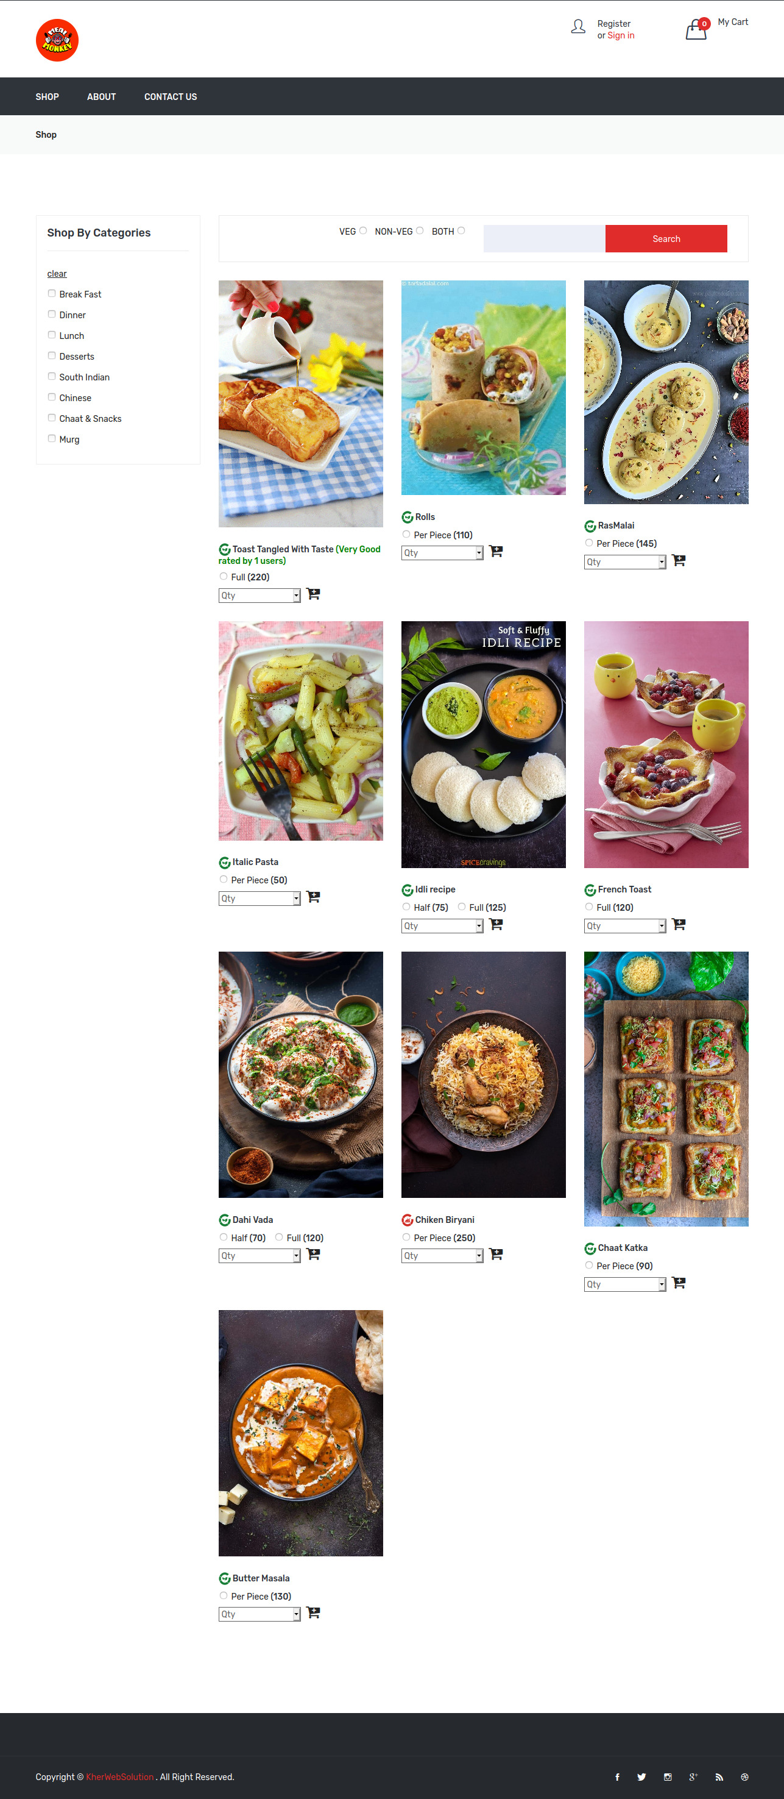**Shop Page**

**About Page**

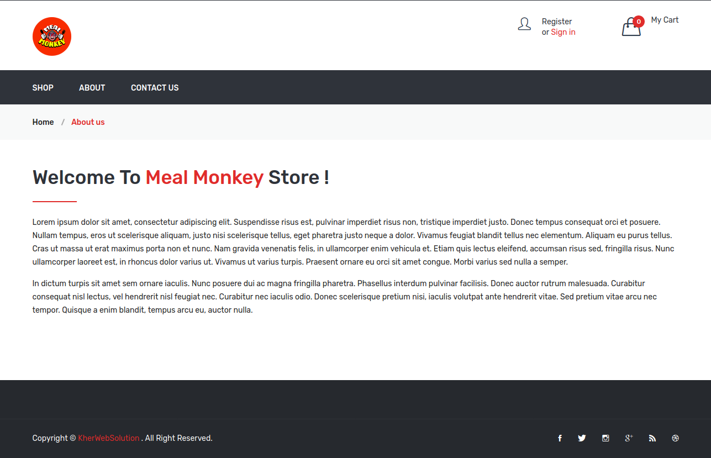

* **Contact Page**

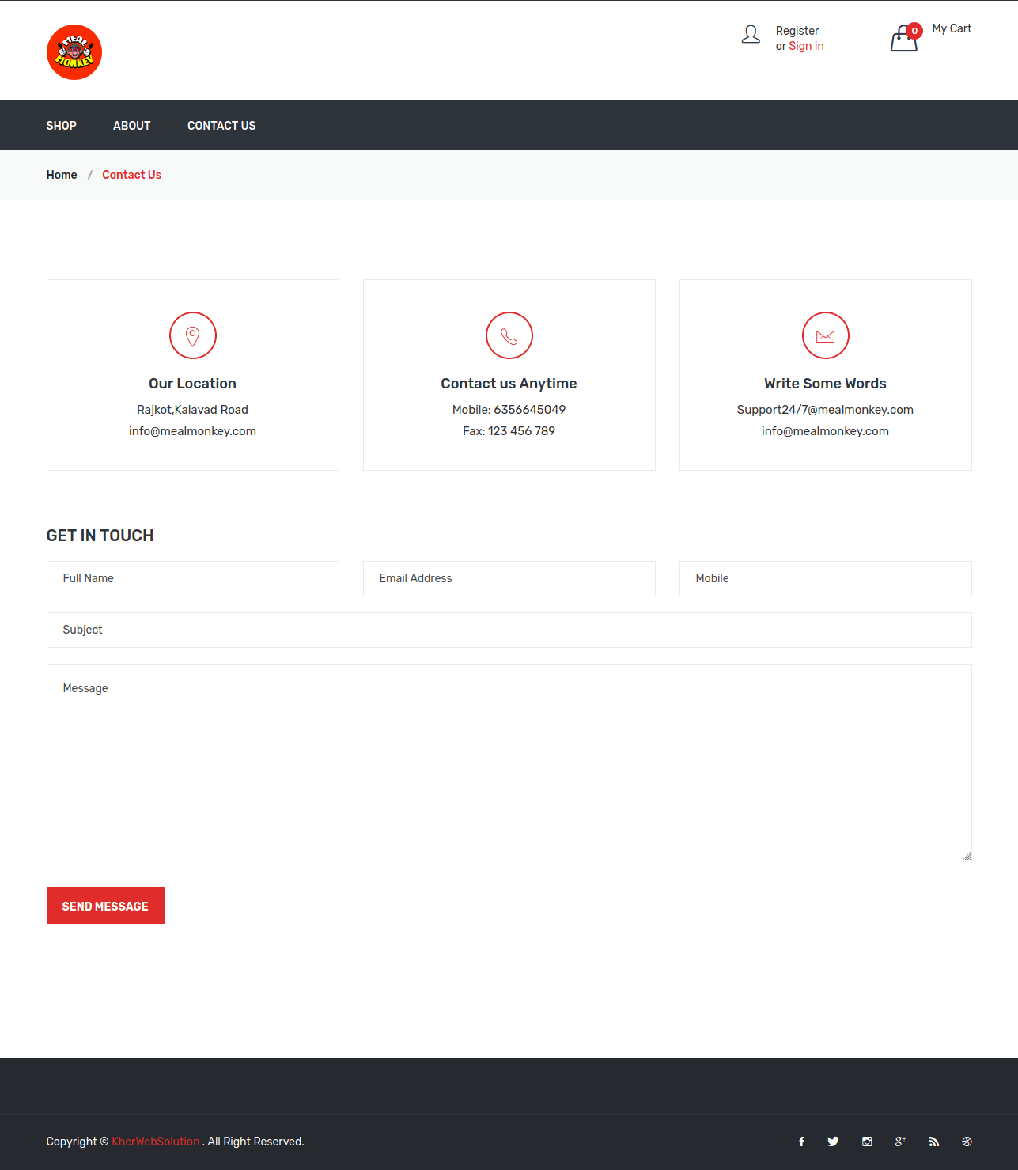

**Cart Page**

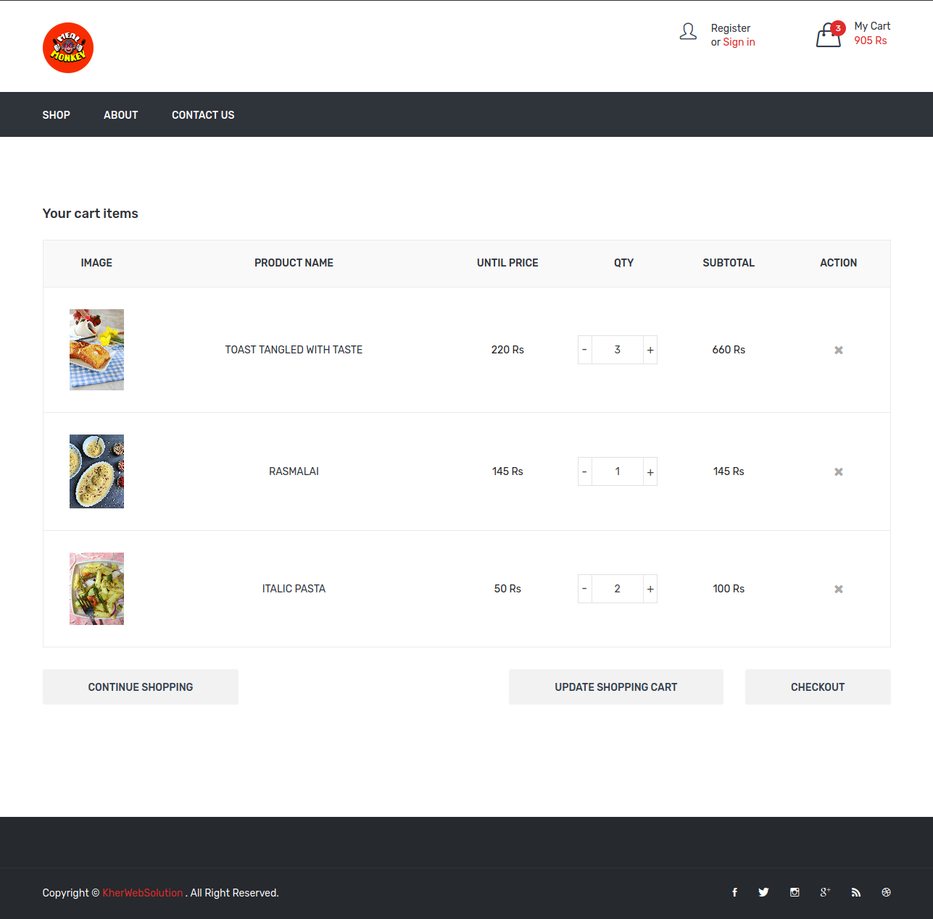

* **Login**

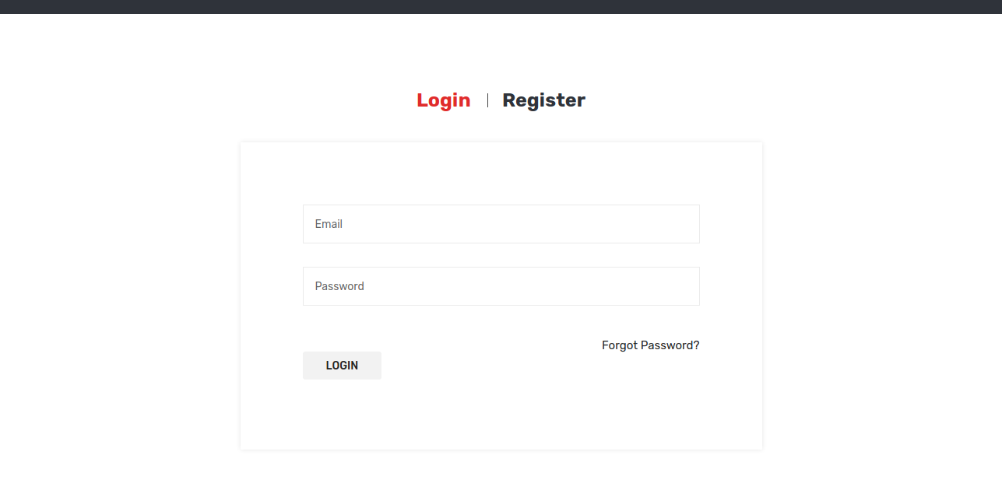

* **Register**

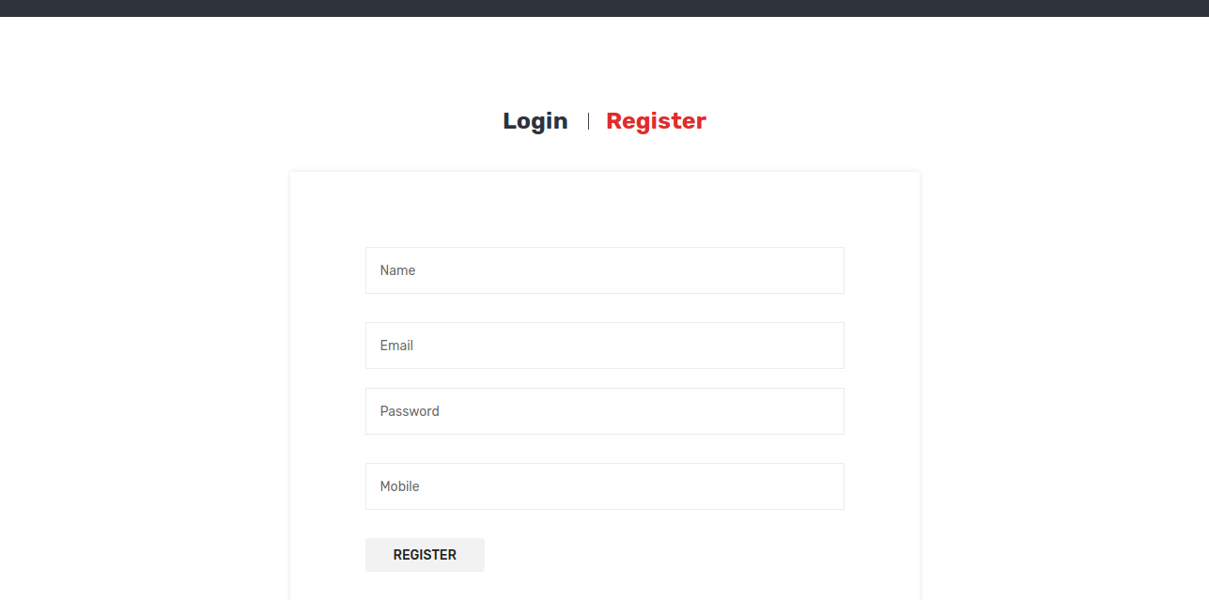

**Checkout Page**

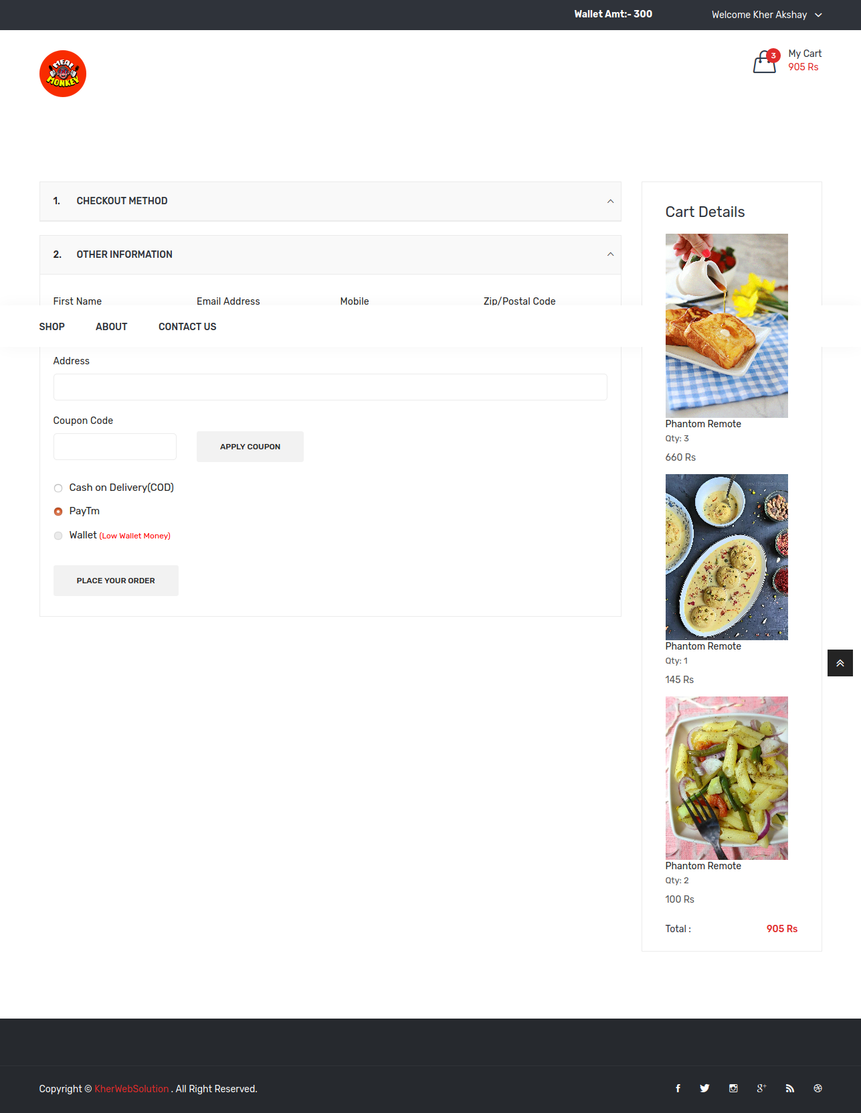

**Profile Page**

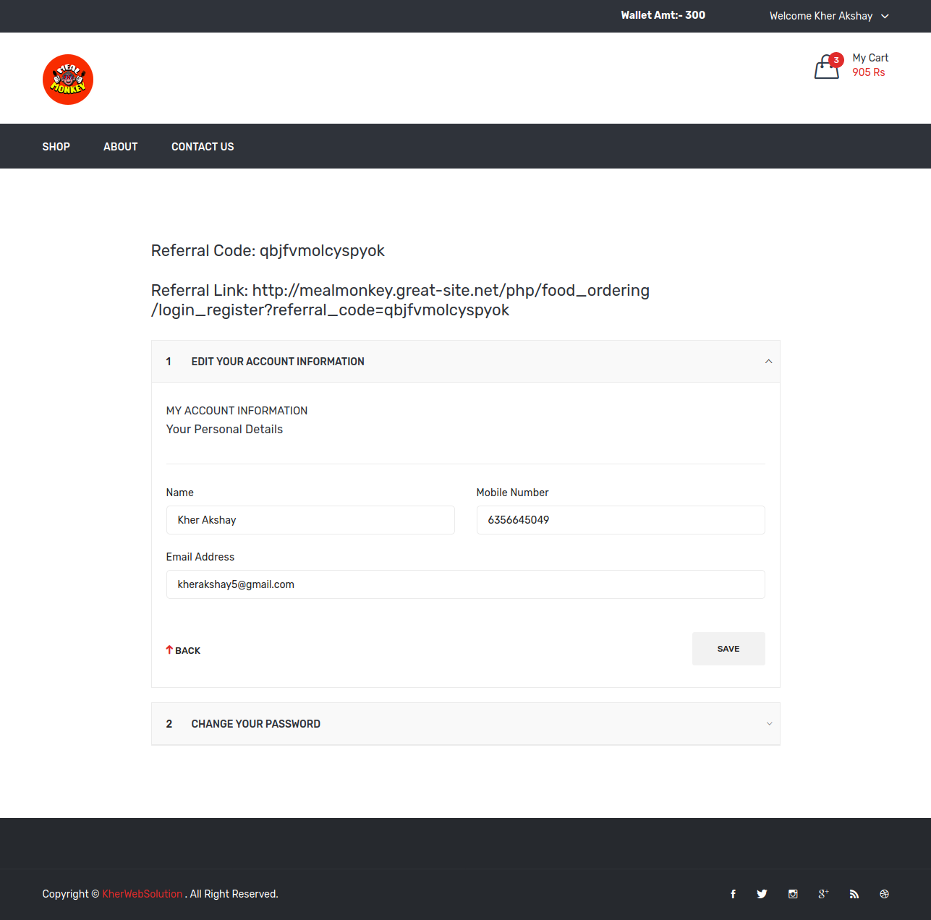

**Order_History**

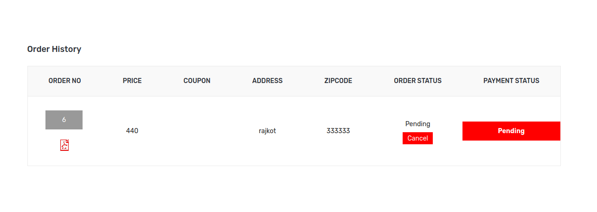

**Payment Process**

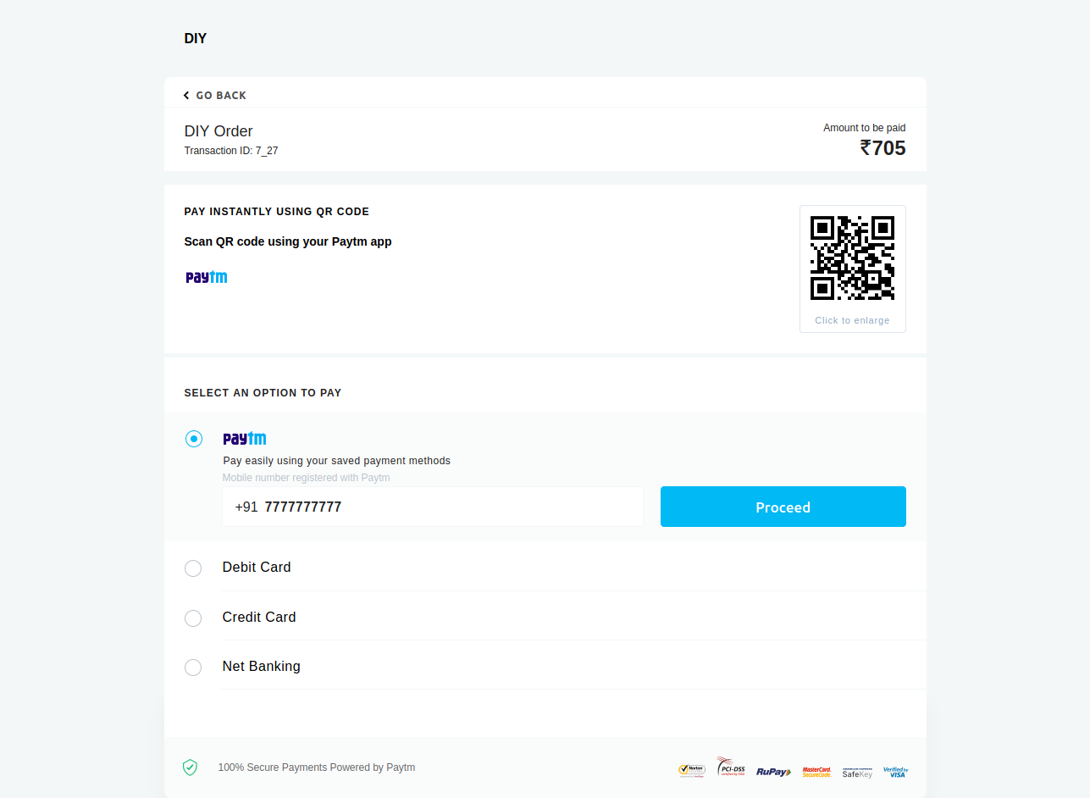

**Wallet Additing Page**

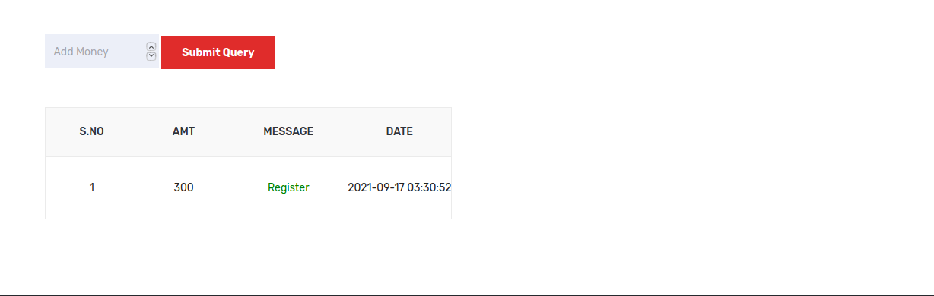

**Delivery Boy Login Page**

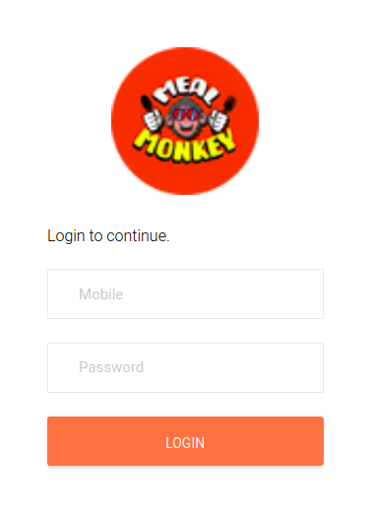

***Delivery_boy Order_Details***

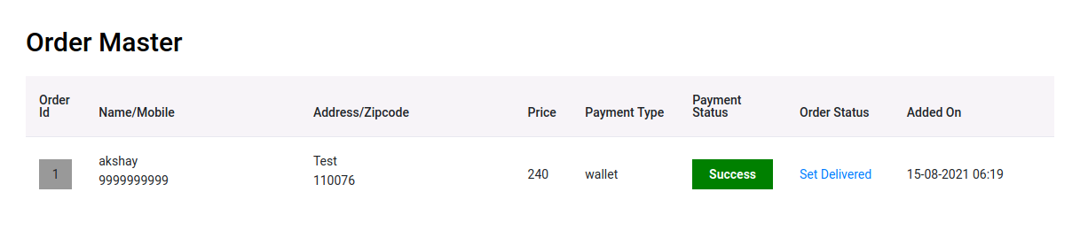

***Admin Side :***

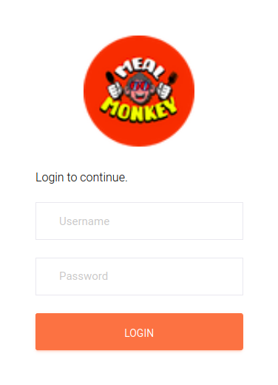❖ **Login Page**

**❖ DashBoard Page**

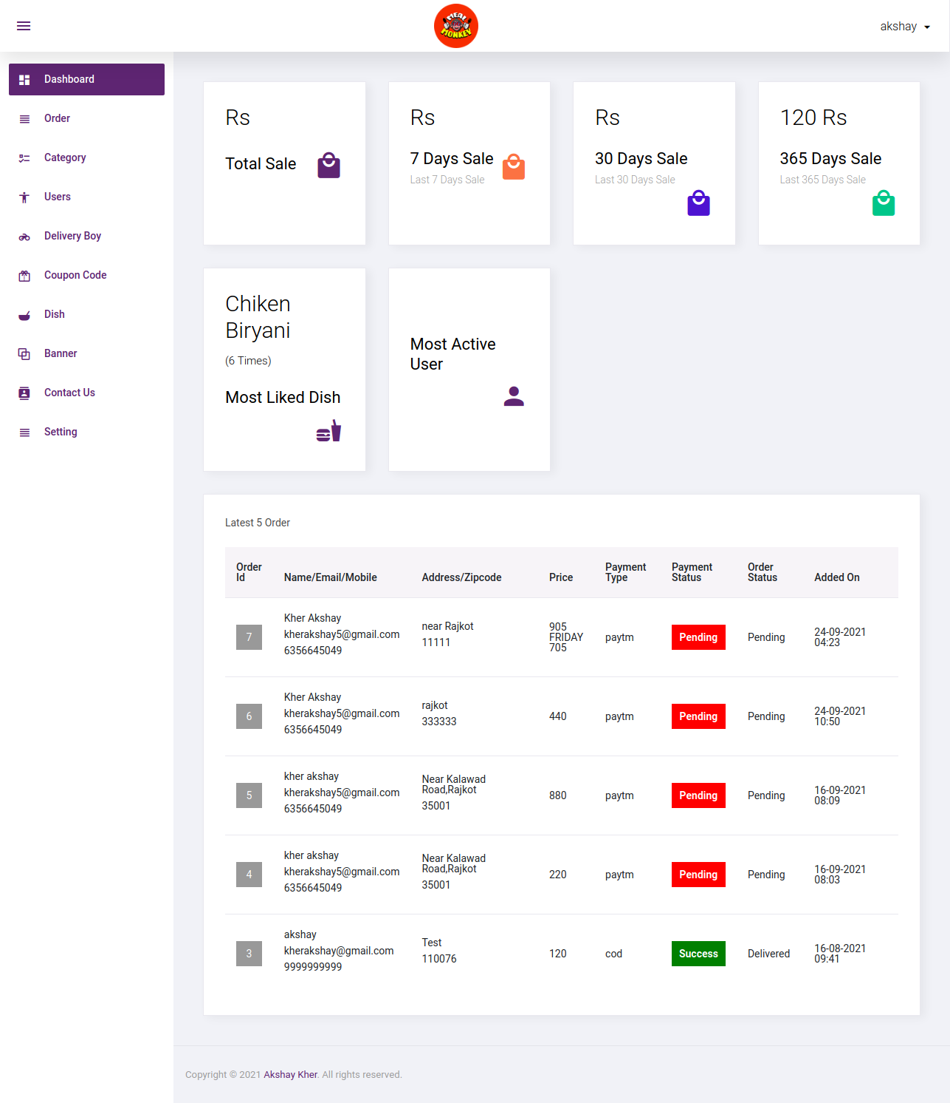

**❖ Order_Details Page**

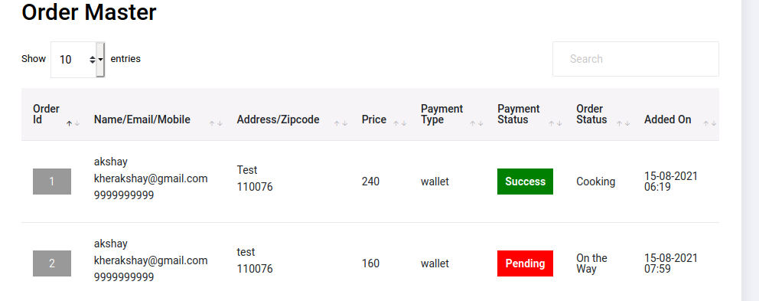

**❖ Category Page**

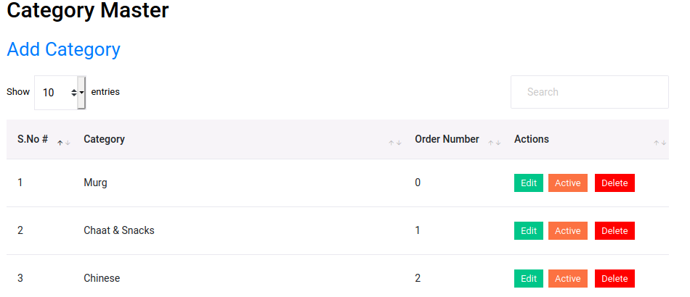

**❖ User Page**

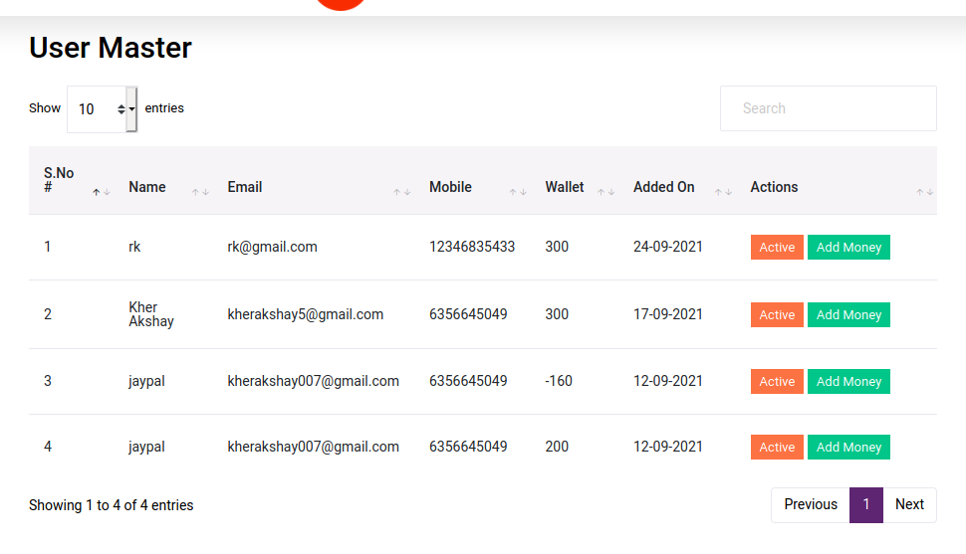

**❖ Delivery_Boy Page**

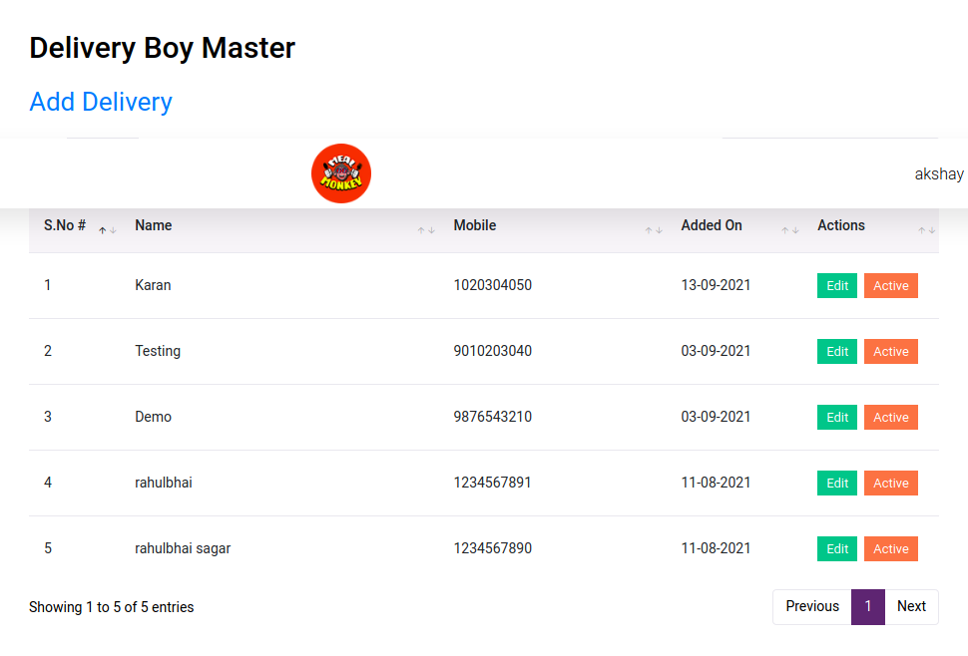

**❖ Coupon Code Page**

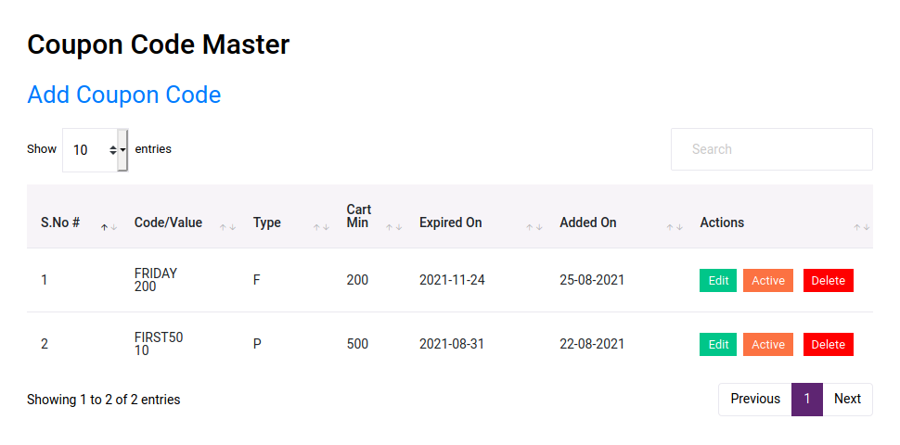

**❖ Contact Us Page**

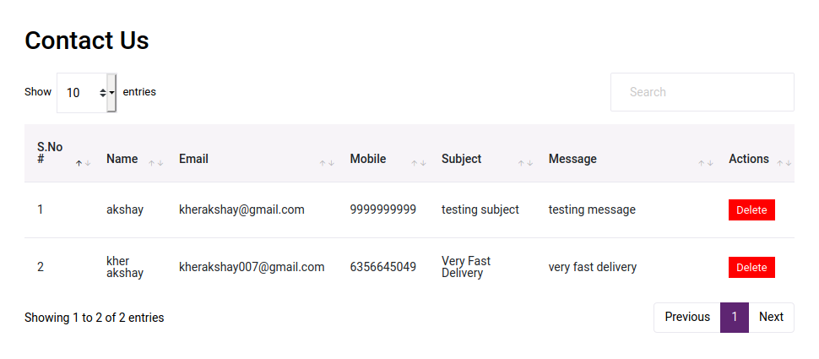

**❖ Dish Page**

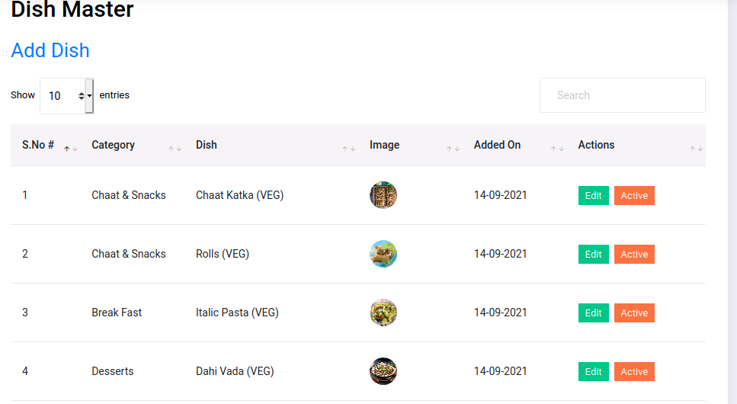

**❖ Banner Page**

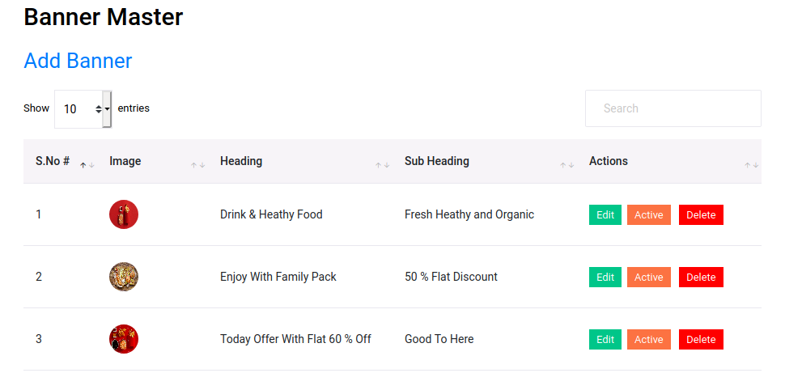

**❖ Setting Page**

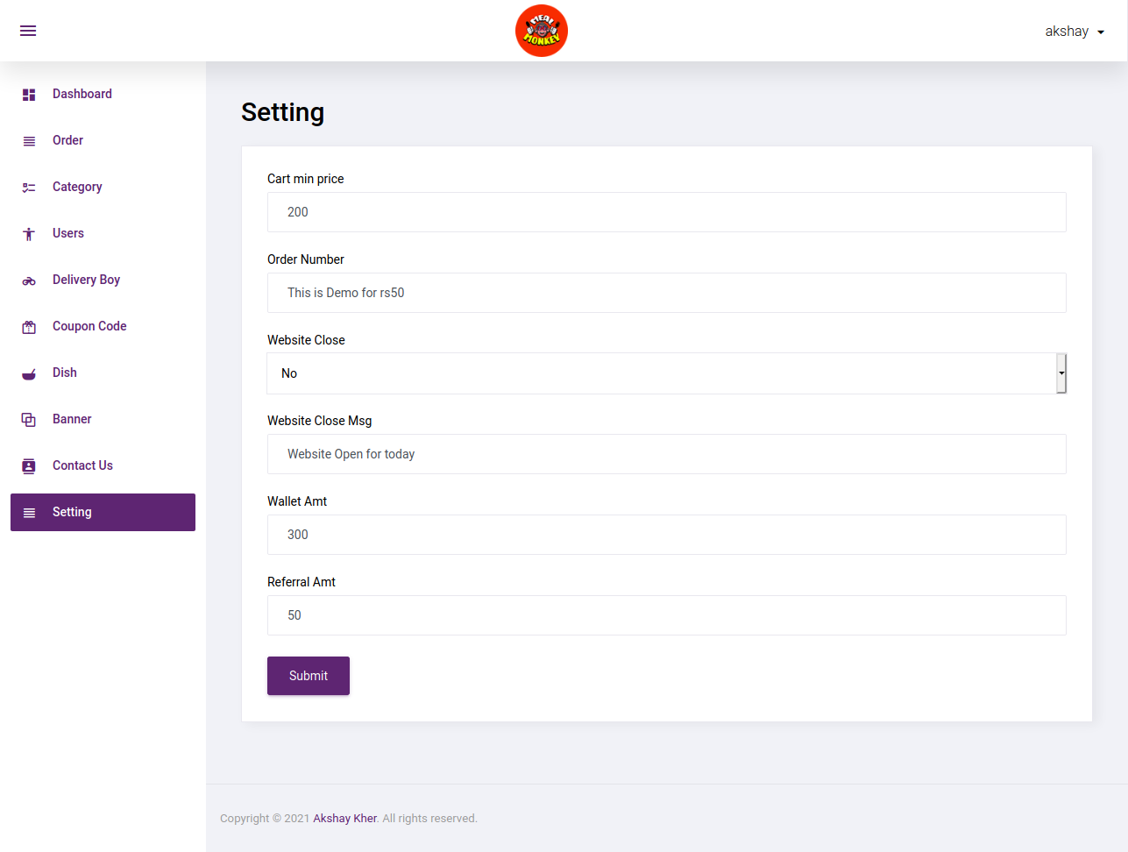

**7**

**TESTING**

**TESTING**

* + - Testing is one of the important steps in system development. Software Testing also provides an objective, independent view of the software to allow the business to appreciate and understand the risks at implementation of the software. Test techniques include, but are not limited to, the process of executing a program or application with the intent of finding [software bugs.](http://en.wikipedia.org/wiki/Software_bugs)
    - Software Testing can also be stated as the process of validating and verifying that a software program/application/product:
    - Meets the business and technical requirements that guided its design and development.
    - Works as expected; and
    - Can be implemented with the same characteristics.
* Software Testing, depending on the testing method employed can be implemented at any time in the development process. However, most of the test effort occurs after the requirements have been defined and the coding process has been completed. As such, the methodology of the test is governed by the Software Development methodology adopted.

**TESTING LEVELS :**

* Tests are frequently grouped by where they are added in the software development process, or by the level of specificity of the test.

**Unit Testing :**

* + - * Unit Testing refers to tests that verify the functionality of a specific section of code, usually at the function level. In an object-oriented environment, this is usually at the class level, and the minimal unit tests include the constructors and destructors.

* + - * These types of tests are usually written by developers as they work on code (white-box style), to ensure that the specific function is working as expected. One function might have multiple tests, to catch corner cases or other branches in the code. Unit testing alone cannot verify the functionality of a piece of software, but rather is used to assure that the building blocks the software uses work independently of each other.Unit testing is also called Component Testing.  **Integration Testing :**
      * Integration Testing is any type of software testing that seeks to verify the interfaces between components against a software design. Software components may be integrated in an iterative way or all together ("big bang"). Normally the former is considered a better practice since it allows interface issues to be localized more quickly and fixed.
      * [Integration Testing](http://en.wikipedia.org/wiki/Integration_testing) works to expose defects in the interfaces and interaction between integrated components (modules). Progressively larger groups of tested software components corresponding to elements of the architectural design are integrated and tested until the software works as a system.

**System Testing :**

* + - * [System Testing t](http://en.wikipedia.org/wiki/System_testing)ests a completely integrated system to verify that it meets its requirements.

**TYPES OF TESTING :**

**Functional Testing :**

* + - * It is an approach to testing where the tests are derived from the program or component specification. The system is a black box whose behavior can only be determined by studying its inputs and the related outputs.
      * **Structural Testing :**

* + - * Structural testing is an approach to testing where the tests are derived from knowledge of the software„s structure and implementation. This approach is sometimes called ‗white-box testing„ to distinguish from black –box testing.

**8**

**FUTURE**

**WORK**

* We have done analysis of this entire system till now, and in future we will develop this system as per our analysis.

* In future this application will became very user-friendly..

* We will covert this web-site into app management so that any user can access our app anywhere through their mobiles
* Bank facilities will be available

**9**

**CONCLUSION**

I have developed *“Kitchenware and Hardware Product” website* in order to overcome the difficulties in managing the existing manual system. The website has been designed effectively keeping in mind, the possible future enhancement and additional functionality; it has been designed to run in an efficient way.

The website is designed to be very user-friendly and interactive manner so that the user cannot find any difficulty while browsing the website. Thereby the proposed website, which is an economically, technically and operationally feasible system has overcome the deficiency that was present in the manual system.

**10**

**REFERENCES**

* This project was impossible to be a success without the support and help from the experience guide; the books and mainly the internet really prove it for us the

“Information Highway”. Everything was really easy to find out on the internet.

* **WEBSITE :**
* [www.w3school.com](http://www.w3school.com/)
* [**www.zomato.com/**](http://www.zomato.com/)
* [**www.swiggy.com/**](https://www.swiggy.com/)
* [**www.dunzo.com/**](http://www.dunzo.com/)
* [**https://stackoverflow.com/**](https://stackoverflow.com/)

#### Last But Not List

1. Github ( Source Code) Link : [**https://tinyurl.com/547vvxpf**](https://tinyurl.com/547vvxpf)

2. C Panel Link :

3. Live Website : [**https://tinyurl.com/h946sejb**](https://tinyurl.com/h946sejb)

4. Admin Panel :